# 

Game Design Document

By Daniel Foth

Overview 2

Objective 3

Character 3

Game Design 3

Game Mechanics 4

Progression 4

Game States 4

Interactions 4

Visual Style 4

Mood board 4

Audio Style 5

Level Design 5

Platforms 5

Obstacles 7

Collectables 8

Sample 9

Unique Mechanics 10

Gliding 11

Fall Damage 11

Endless Platforming 11

User Interface 11

Menus 12

HUD 14

Gray Box User testing 15

Asset Development Plan 16

Interfaces 17

3D Models 17

Audio 17

Roadmap 17

# Overview

Descent into Madness is an Alice in Wonderland inspired game where the player descends the rabbit hole. The game is an Endless Platformer where the further the player gets the faster and crazier the game gets.

The game's uniqueness comes from a need for the player to manage their descent downwards while minimizing the fall damage. To do so they have limited use of an umbrella that can be used to float downwards slowing their descent.

## Objective

The player's goal is to score the highest score they can before they run out of health. The score increases depending on the collectable they collect on each platform.

## Character

The player plays a young girl that has fallen down an endless rabbit hole. Her only choice is to head down in the hopes that this hole has a bottom.

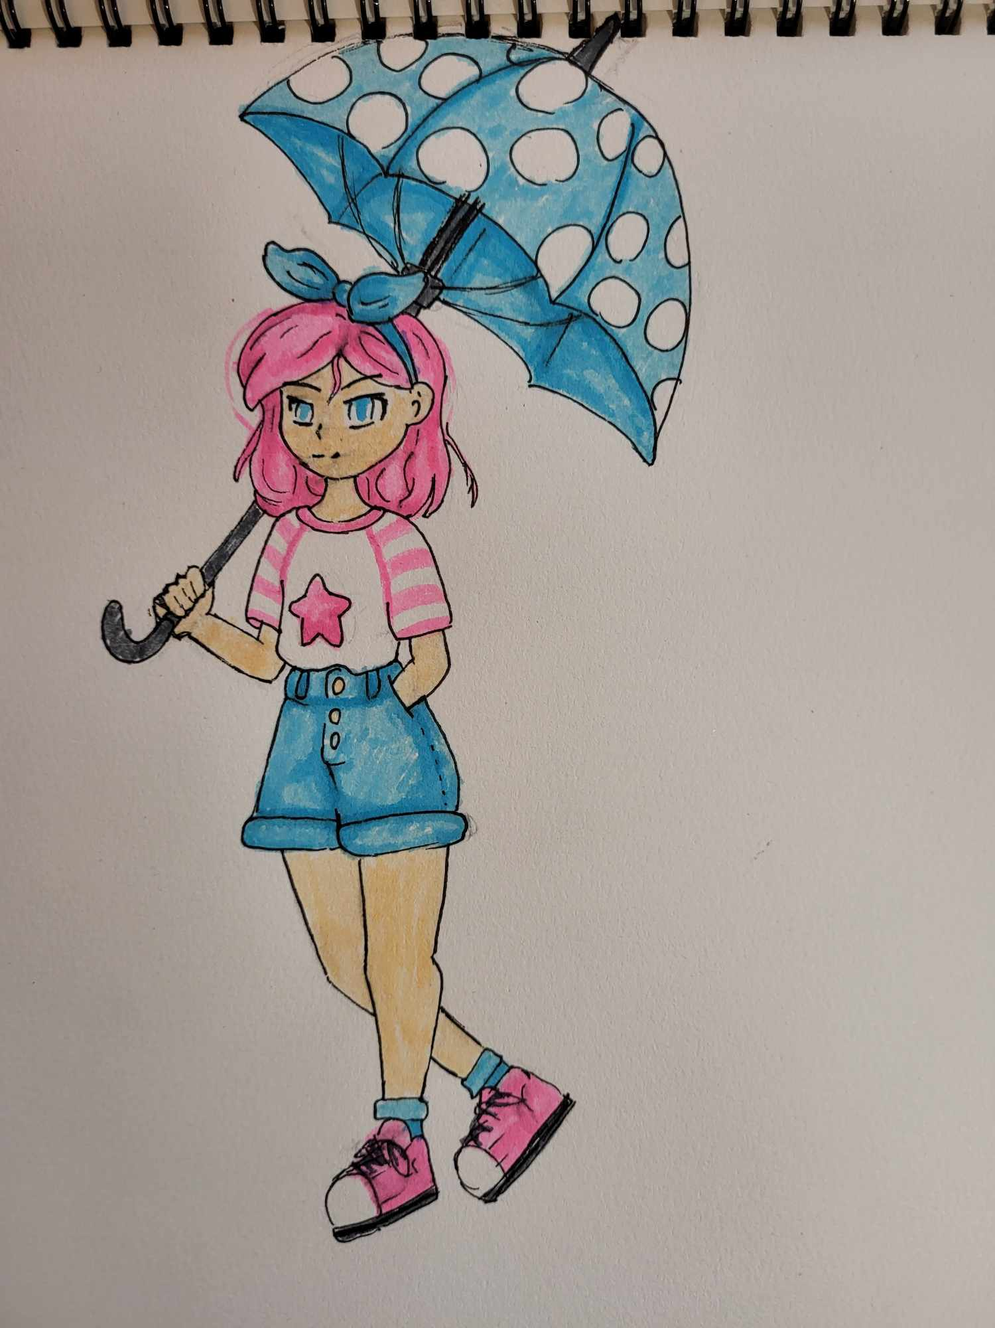

On her descent, she must avoid obstacles that send her flying up and down and platforms that vanish under her feet.

# Game Design

## Game Mechanics

The player jumps from platform to platform, as their speed increases so does the damage they take when they land. They have limited use of the umbrella which slows their fall allowing them to stay in control of the main characters' descent. The player needs an indication of how much damage they will take, this will be solved by a gradient creeping into the HUD described in a section below.

The player can increase their score by collecting randomly generated pickups on each platform. Some of which have special effects as described in the Level Design section below.

Platforms disappear after their time runs out, which is indicated by forcing the player into quick decision making and giving them limited time to recover their umbrella.

## Progression

As the player makes their descent the game loop speeds up and becomes more chaotic. The platforms disappear faster, start moving and even move faster and more chaotically.

## Game States

The game only has a game over state. This shows the player their current and high score. It also gives them the opportunity to quit or try again.

## Interactions

The player can interact with the keyboard or controller.

|  |  |  |
| --- | --- | --- |
| ***Control*** | ***Keyboard & mouse*** | ***Controller*** |
| movement | wasd | Right analog |
| jump | space | X |
| glide | space | X |
| camera | Mouse movement | Left analog |

## Visual Style

The game will have a pastel color pallet with mainly blues and pinks. Darker pinks and reds will signify danger. The hole should look pitch black and bottomless.

## Mood board

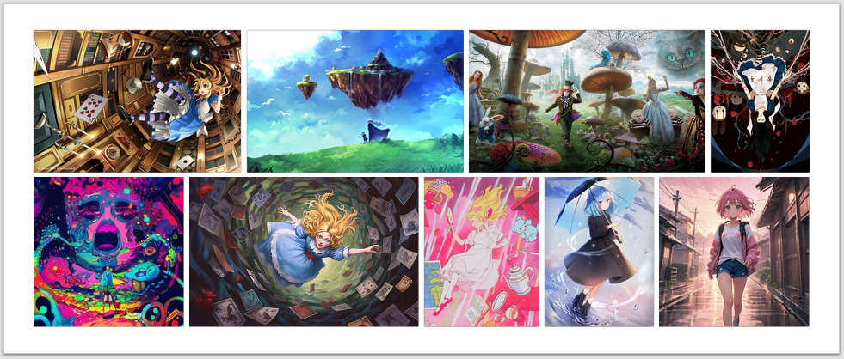

## Audio Style

The game will have jazz music as the main track. Initially this track should be a cozy bop, but it will speed up as the game speeds up. The track will also become more distorted and pitchy as the player makes their way downward. It starts off being cozy and eventually turns maniacal.

Sound effects for running, jumping and landing will be needed for the player character.

Obstacles should make ominous sounds that indicate something is amiss, while collectables should attract the player.

# Level Design

## Platforms

The platforms consist of multiple objects. These Include:

1. Grass top
2. Rocky Bottom
3. Collectable which the player needs to pick up to increase their score.
4. Lamp which signifies how long the platform has left to exist.
5. Particle effect that implies an island is floating.

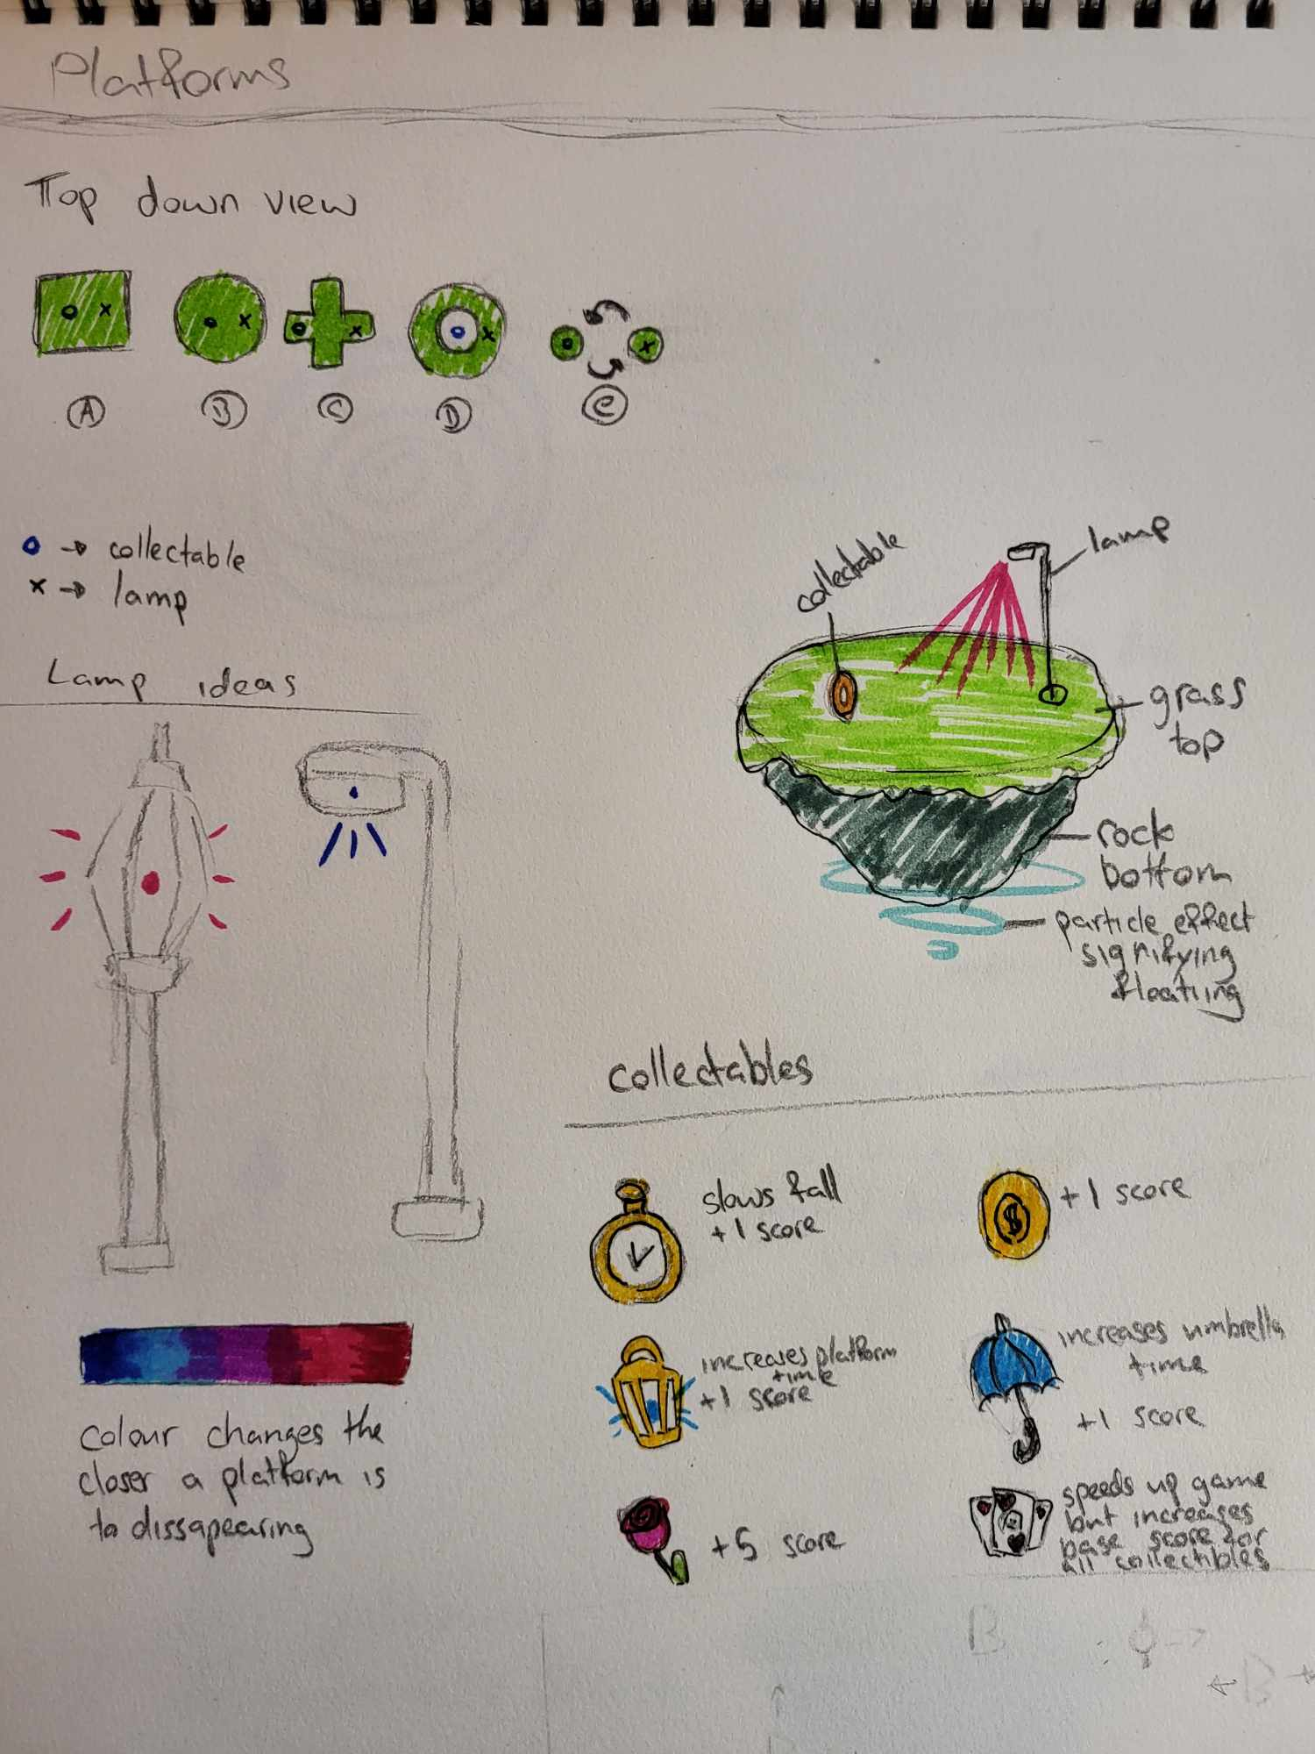

There are 6 platform shapes. Platforms c, d and e are more complex and will not spawn at the start. Platform d will force the player through the middle if the player wants the collectable, It's a high-risk option. Platform e will rotate making it hard to land on.



The lamp will glow from blue to red. This will signify how much time a platform has left before it disappears. The lamp on right will be used in the game as it's more visually pleasing.



## Obstacles

***Black Hole***

The black hole pulls the player on and spits them out at the bottom. It also accelerates the player’s speed to inflict damage

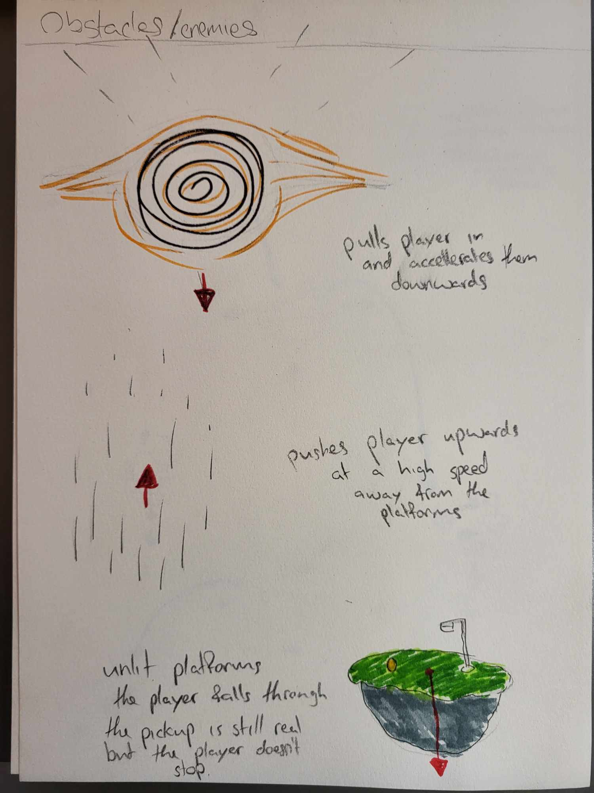

***Updraft***

The updraft sends the player upwards at a high speed. They lose valuable time and will accelerate downwards more than before due to the height gained. If timed right it could be used to save the player from damage.



***Trick Platform***

This is a platform that vanishes when the player touches it. The collectable is the only real bit about the platform, the player needs to catch it midair if they want it. A trick platform can be told apart from the rest as it's not lit up.



## Collectables

There are multiple collectables, each adds to the players score with some adding more than others.



|  |  |  |
| --- | --- | --- |
| Collectable | Score | Effect |
| Clock | +1 | Slows fall speed for a limited time |
| Coin | +1 |  |
| Lamp | +1 | Increases platform time to live |
| Umbrella | +1 | Increases umbrella stamina allowing longer gliding |
| Rose | +5 |  |
| Cards | +1 | Increases speed of game and adds +1 to score of every collectable from this point onwards. |

## Sample

Below is a sample level with all the objects described above. There is an optimal route through the level for the player to take with some obstacles to avoid.

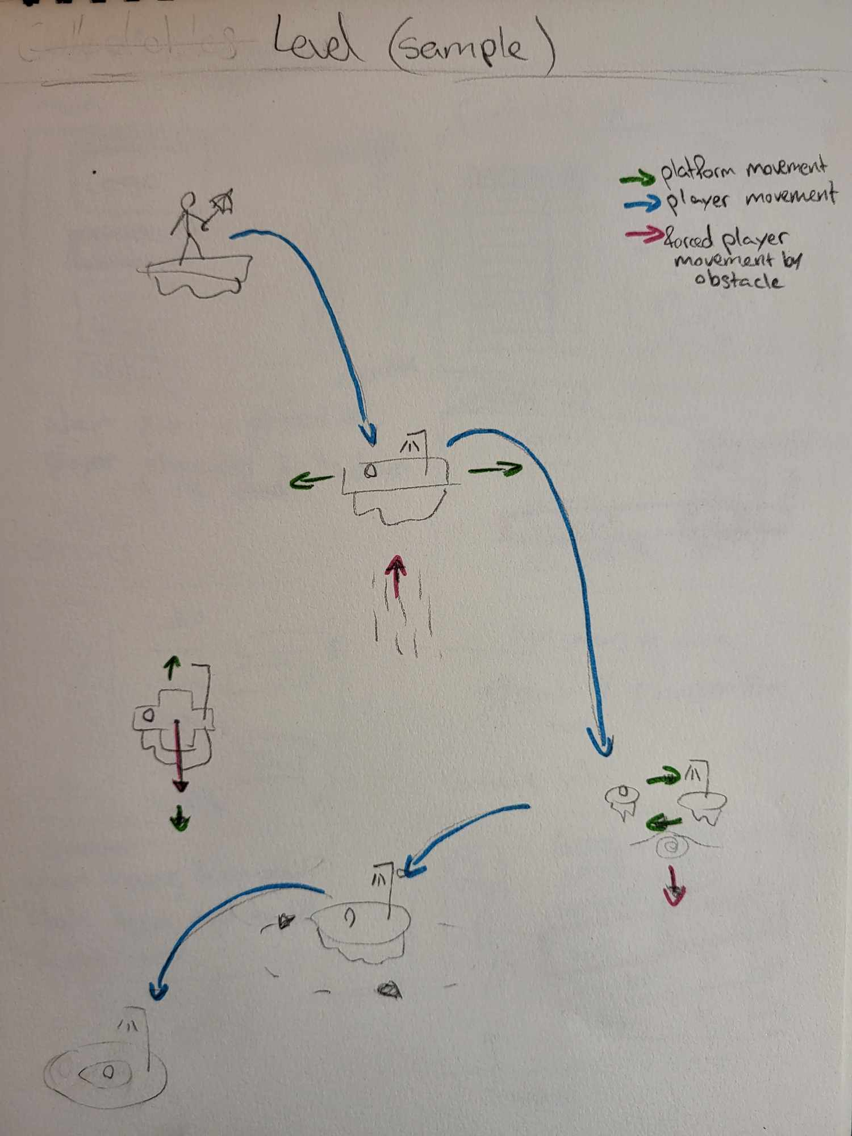

# Unique Mechanics

## Gliding

The player can press the action key (space/X) to glide midair. This will slow the player down over time. minimizing the amount of fall damage, they take. When the player is not gliding, they will accelerate downwards until they reach a terminal velocity. This will require user input and a force that works against the acceleration due to gravity.

## Fall Damage

The player takes fall damage based on how fast they land on a platform. Hitting the platform at thermal velocity is an instant game over. This will require acceleration due to gravity on the player character.

## Endless Platforming

As the player goes downwards new platforms will spawn. There will always be 5 platforms available below them. Any platforms they pass will be destroyed and more will spawn below. This will require a platform spawning blueprint that can generate platforms with decent parameters that will make for a fun experience for the players.

# User Interface

## Menus

The menus will have a similar color aesthetic to the game, using the same skybox and colors for different UI elements. The main character is going to be present on the menu, gliding downwards.

***Main Menu***

From the main menu the player can do the following:

1. Play – starts the game, when this is pressed an animation of the character falling off the screen plays, implying they are gliding into the level.
2. Controls – displays the controls to the player
3. Options – allows the player to change audio and graphics settings
4. Exit – quits the game

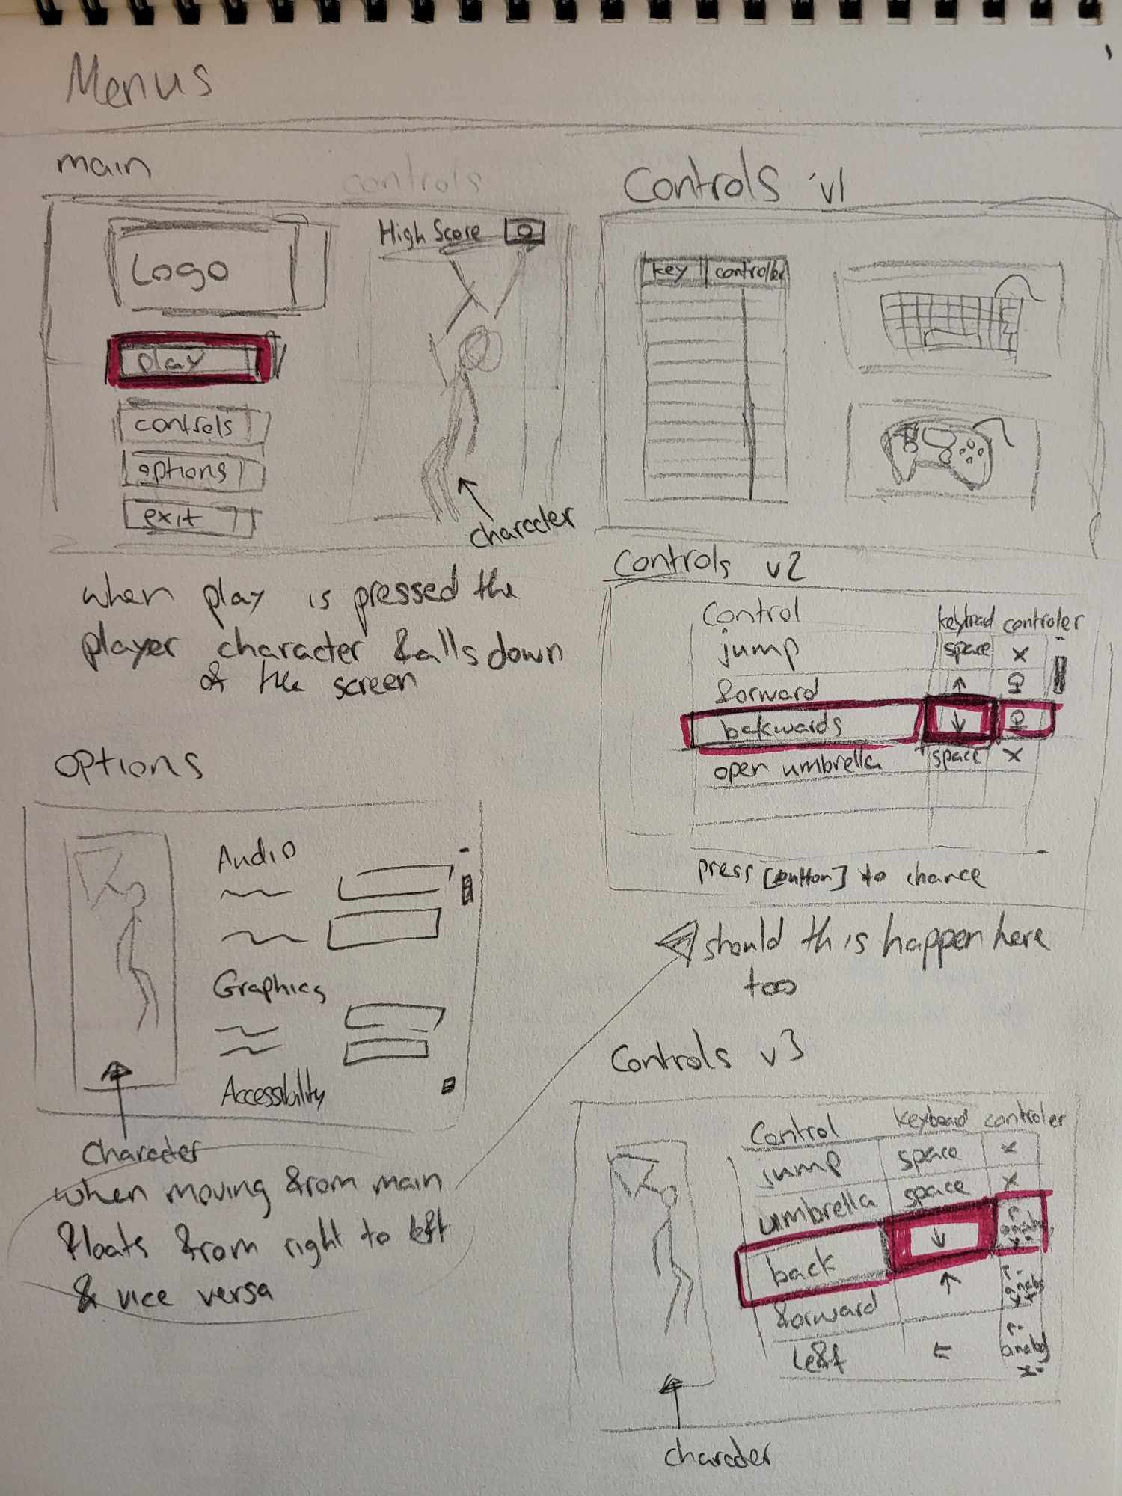

***Options***

When Options are selected from the menu the player glides from right to left along with the new options. These include Audio and Graphics options. The player can go back to the menu, this will play the glide in reverse.



***Controls***

Like with Options the same kind of animation plays out with controls. This menu displays the keyboard and controller inputs. It also should allow the player to update key bindings.



***Pause Menu***

The player can pause the game allowing them to quit at any time. Any score that exceeds the high score should be saved on exit.

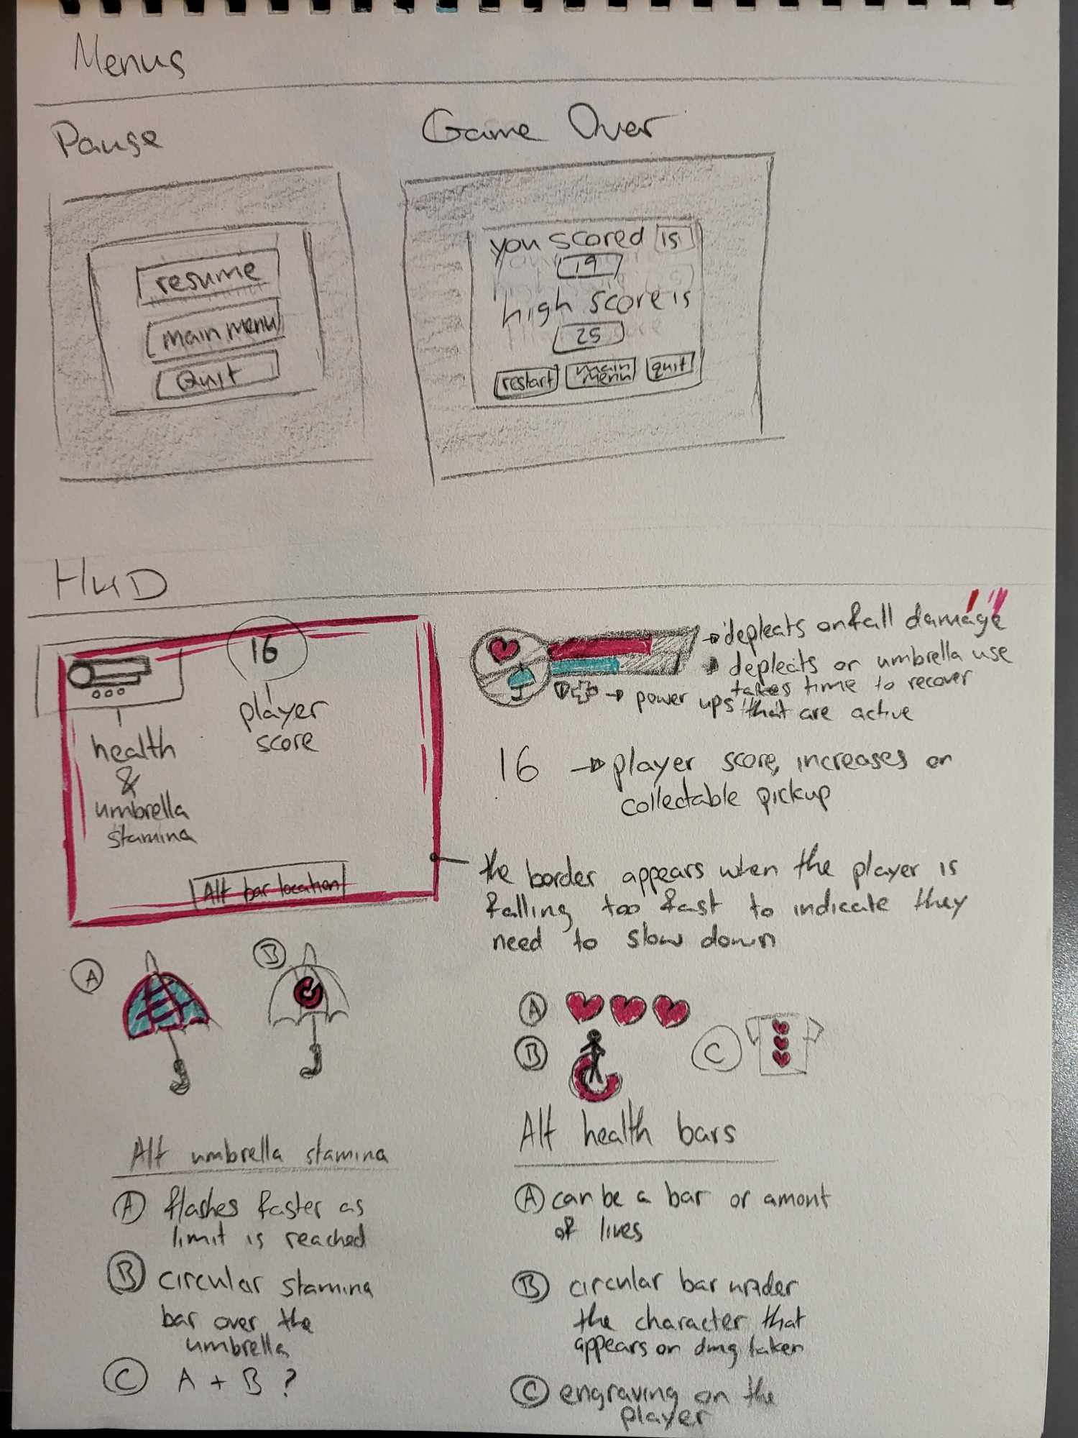

***Game Over Menu***

When the player runs out of health their current score and existing high score will be displayed on the screen. They can start over or quit from this menu.



## HUD

The HUD consist of multiple elements, these include:

* Player health bar - shows the player the amount of health until the game ends.
* Umbrella durability - signifies how much time the player can glide for.
* Border those creeps in as the player descends at too high a speed, indicating fall damage.
* Players Score – shows the player how well they are doing.



After evaluating the above concept, it is decided that simple bars will be used for health and durability.

# Gray Box User testing

The test consisted of 8 people. The results of the survey can be found in the onedrive/github in the UserTesting/GrayBox directory.

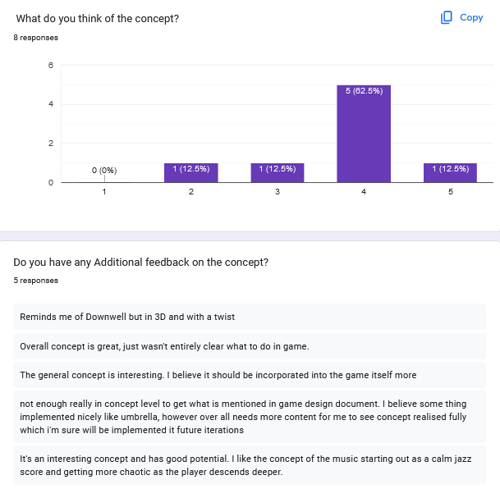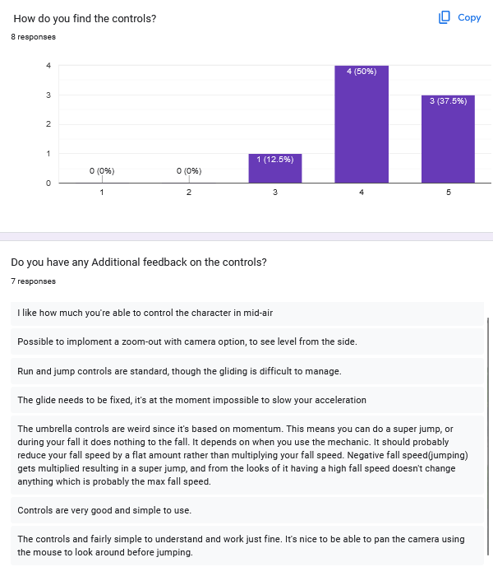

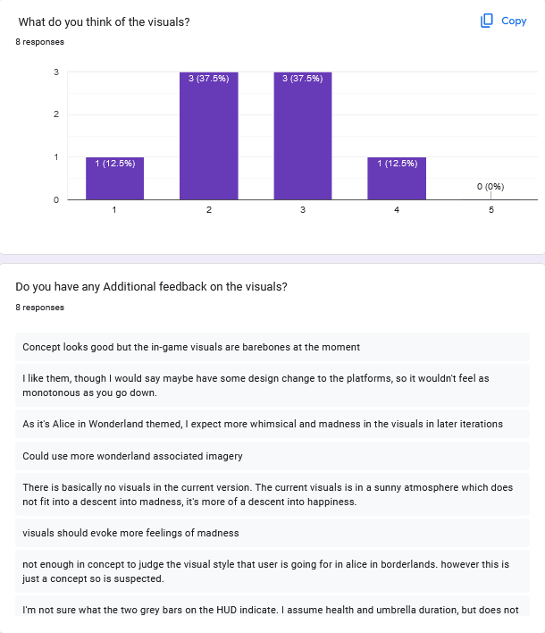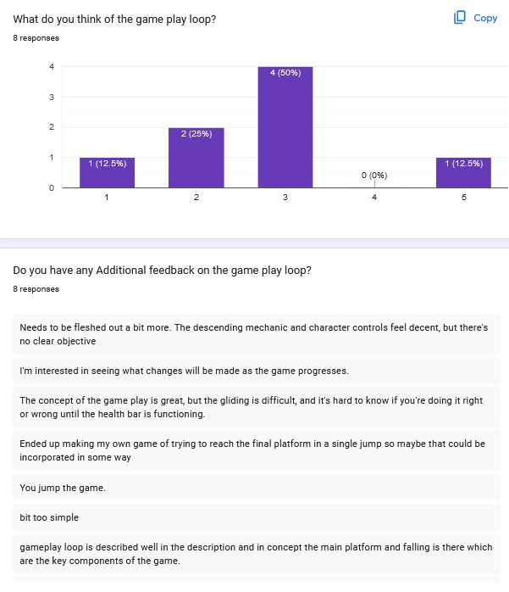

The concept was well received, people generally showed some level of interest in the idea. The users would like to see more of the Alice In Wonderland aesthetic as the current environment is a bit bland.

The gray box didn't have a well-defined goal. This was the biggest weakness in the prototype but the concept itself has a very well-defined goal which should solve this issue for the Alpha.

The gliding mechanic in gray box had some issues, especially around deceleration, but generally the controls felt solid. Simple and easy to understand controls played a big part here. Some players would also like to be able to zoom out the camera to see the environment better.

The gray box is also too simple and repetitive for some. This will be addressed with a variety of platforms, collectables and obstacles.

Key Feedback to work on for alpha release pulled directly from survey:

1. clearer goal needs to be established
2. platforms further apart so you need to use the umbrella mechanic
3. The circles (which I'm assuming are pickups) are not working
4. bit too simple, needs to be fleshed out a bit more
5. visuals should evoke more feelings of madness
6. Could use more wonderland associated imagery, in-game visuals are barebones

# Asset Development Plan

The assets will be pulled into UE5 to make the project.

## Interfaces

Interfaces will be made in UE5, any visual assets needed will be made in Krita. Krita is a free drawing and photo editing tool.

## 3D Models

All 3D models will be made & textured in blender and imported into UE5. Textures may be edited in Krita when using real life photos for textures.

## Audio

All audio assets will be sourced with a Creative Commons license from <https://freesound.org/>. They will be edited with Audacity as needed to fit with the vibe of the game. Audacity is a sound editing tool.

# Roadmap

The road map was made using <https://www.onlinegantt.com/#/gantt>

